Assignment 8: Adversarial Machine Learning Defenses
CSC 592: Machine Learning Security and Privacy

Part 1: Literature Reading Questions

Read the Abstract, Introduction (section 1), Methodology (section 3) and Recurring Attack Themes (section 4) from the paper, “On Adaptive Attacks to Adversarial Example Defenses”, by Tramer et al.: https://arxiv.org/abs/2002.08347.
Q1. Is there a single unified attack strategy in the paper that can be used to break all of the defenses?

Q2. How many defenses in the paper withstood the adaptive attacks performed by Tramer et al.?

Q3. Based on Table 1 in the paper, which attack theme occurred the most often? In your own words explain what this attack theme means.

Q4. Briefly read section 8 of the paper (Robust Sparse Fourier Transform), specifically focusing on section 8.2. What mistake in the security analysis did the original authors of the Robust Sparse Fourier Transform defense make? Which other defense technique in lecture also suffered from the same issue?

Part 2: Theory Questions

Q5. The Randomized Multiplexer Defense
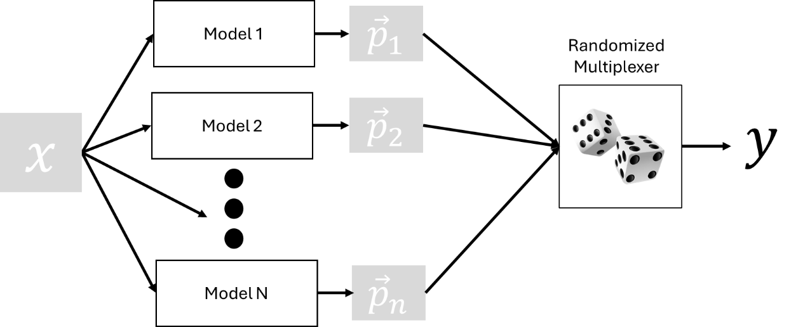
Consider the Randomized Multiplexer Defense shown above. The defense works as follows: input $x$ is given to each of $n$ vanilla ResNet models. Each model $j$ produces an associated softmax output (probability vector) ${\vec{p}}_{j}$. Next an $n$ sided dice is rolled to generate an integer value $i$. The output for the defense is $y=max⁡({\vec{p}}_{\left(i\right)})$ where ${\vec{p}}_{\left(i\right)}$ is the softmax output of the $i^{th}$ model. Write the pseudocode for a PGD white-box attack algorithm to break this defense? In 2-3 sentences describe why this attack will be

Q6. The k-winner take all defense creates models where certain layers use a specialized activation function (k-WTA). Below is an example for k-WTA where k=3 and the generalized activation function equation:
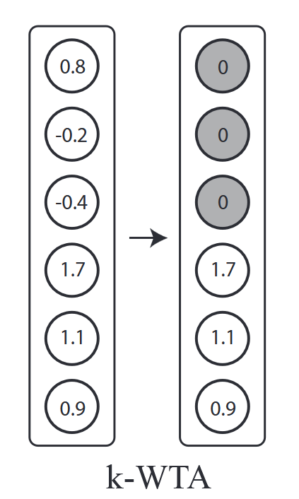
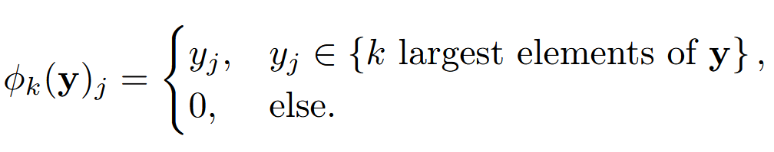
where $y$ is the input vector to the activation function. In the original k-WTA defense paper, white-box attacks are run on the model and shown to be ineffective. In addition, the paper essentially says the following, “the paper tests against transfer-based attacks. While it argues that ‘generating adversarial examples from an independently trained copy of the target network’ is the strongest black-box attack” (source of the quote: https://arxiv.org/pdf/2002.08347). Consider the following: a pure black-box attack where the synthetic model is a k-WTA network and the model being attacked is an independently trained copy of a k-WTA network. Is such an attack valid? Explain why or why not. Then explain what attacks you might try to reduce the k-WTA network robustness?

Q7. Part A. Consider the case where you have a group of 5 friends (including you) that are deciding where to eat. The choices are an Italian, Chinese or Indian restaurant. The group goes out to eat based on voting. The rule is that the group will go to the restaurant that receives the majority of the votes (assuming no tied vote). Under this setup, how many people do you need to convince to vote for Italian, in order to go to the Italian restaurant?

Q7. Part B. Consider the case where you have $n$ different models in a multi-model defense and the classification is binary (a two class problem). When running an untargeted attack, how many models must misclassify $x_{adv}$ if hard label majority voting is used? Show all steps used to obtain your answer.

Q7. Part C. A new defense is proposed for a 5-class classification problem. The defense is called, “The 300 Spartans”, because the number of models is $n=300$. The defense uses hard label majority voting. The authors of the 300 Spartans defense claim that their method is extremely strong because in order for a targeted attack to break the defense, at least 151 models must produce class label $t$. Is this reasoning correct? Explain why or why not.

Q7. Part D. Instead of majority voting, consider absolute consensus voting. In this scheme if all models agree on class label $y$ then the class label $y$ is given as the output. If any of the $n$ classifier has $C(x)≠y$, then instead the defense returns an “adversarial label”. The adversarial label means the defense thinks an attack is being done and requests human intervention for classifying $x$. If an adversarial example $x_{adv}$ is labeled as adversarial then the attack is considered to be a failure. Would an absolute consensus voting defense be harder to break than the 300 Spartans defense, assuming the same models are used in both? Could you think of any potential drawbacks to the absolute consensus voting scheme?

Q8. Gray-box threat models are an intermediate step between white-box and black-box threat models. Consider the following gray-box threat model: the attacker has access to the model architecture, loss function and query access to the model. In addition, we have a clean example $x$ that we want to make adversarial with maximum perturbation $ϵ_{max}$. However, a secret non-randomized transformation $S(∙)$ is applied to the input $x$ before passing it through the model: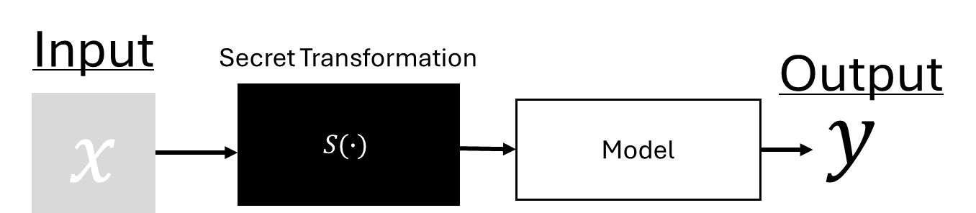
We are allowed to backpropagate through the model but not through $S(∙)$. We are allowed to observe the input and output of $S(∙)$. The authors publish this paper as, “Secrets Are All You Need Against Adversarial Examples”. In the paper, they run white-box attacks on the model, then show that the above setup of the model plus secret classifies the adversarial examples correctly. Explain whether or not this defense is secure? If it is not secure, develop a gray-box attack based on the previously mentioned threat model?

Q9. Consider the Barrage of Random Transforms (BaRT) defense where a series of image transformations are applied in a random order and each transformation has an associated randomized intensity $θ$. Give the pseudocode for a modified version of the PGD algorithm to work on Barrage of Random Transforms defense?

Q10. Your friend Bob is very impressed with the robustness of adversarial trained models. However, Bob notices that the adversarially trained models do not perform as well on clean examples, as compared to models that are trained in a standard manner (no adversarial training). To keep the accuracy on unperturbed data high, Bob suggests the following scheme:
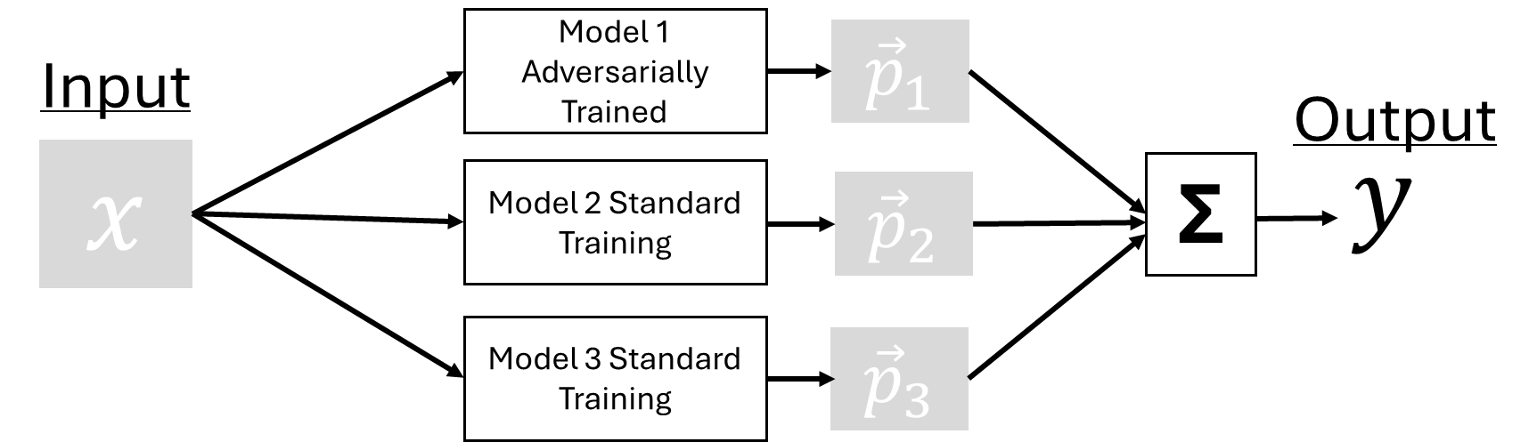
Assume that the robustness of model 1 to adversarial examples is 50%. The robustness of model 2 is 0% and the robustness of model 3 is also 0%. Explain why Bob’s defense is not effective. Write the pseudocode for a PGD white-box attack to break Bob’s defense?

Q11. Consider the general steps for adversarial training as follows:
1. Randomly initialize the weights of model $m$ to get $w^{(0)}$.
2. For $e$ in range $(0,E)$:
3. $X_{adv}←PGD\left(X,ϵ_{max},m,w^{\left(e\right)}\right)$
4. Train $m$ on $(X_{adv},Y)$ to get $w^{'}$
5. $w^{(e+1)}←w^{'}$
6. Return trained model $m$ with weights $w^{\left(E\right)}$

Bob is impatient because his model is taking a long time to train with the above algorithm. Bob proposes removing the PGD step from the for loop and doing adversarial training in the following manner:
1. Randomly initialize the weights of model $m$ to get $w^{(0)}$.
2. $X_{adv}←PGD\left(X,ϵ_{max},m,w^{\left(0\right)}\right)$
3. For $e$ in range $(0,E)$:
4. Train $m$ on $(X_{adv},Y)$ to get $w^{'}$
5. $w^{(e+1)}←w^{'}$
6. Return trained model $m$ with weights $w^{(E)}$

Explain why Bob’s adversarial training algorithm will or will not perform better in terms of robustness than the original adversarial training algorithm? Justify your answer with appropriate reasoning.

Deliverables
Submit the following item on Brightspace:
Deliverable #1: A document containing the answers to the questions from part 1 and part 2 of the assignment.

